Report ID : 111ABC123(Unique identifier number)

Title : no error message is displayed when the "Message" field is empty

Summary : when the user Navigates to the Contact Us menu option and select Contact button under Marketing section. A form appears on the screen. if the user Fill the form by excluding the Message field, the user is not presented with any error message indicating that the message field is mandatory.

Date : 17-01-2024

Author : Ahad Khan

Issuing organization : LTIMindtree

Configuration item being tested : Message field in marketing form
Link : https://www.tendable.com/contact-us

Expected results : An error should be displayed when message field is left empty.

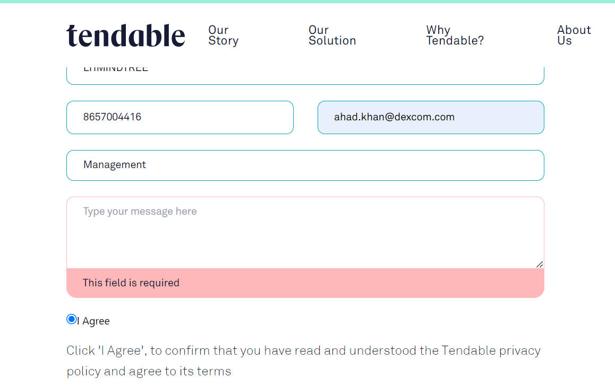

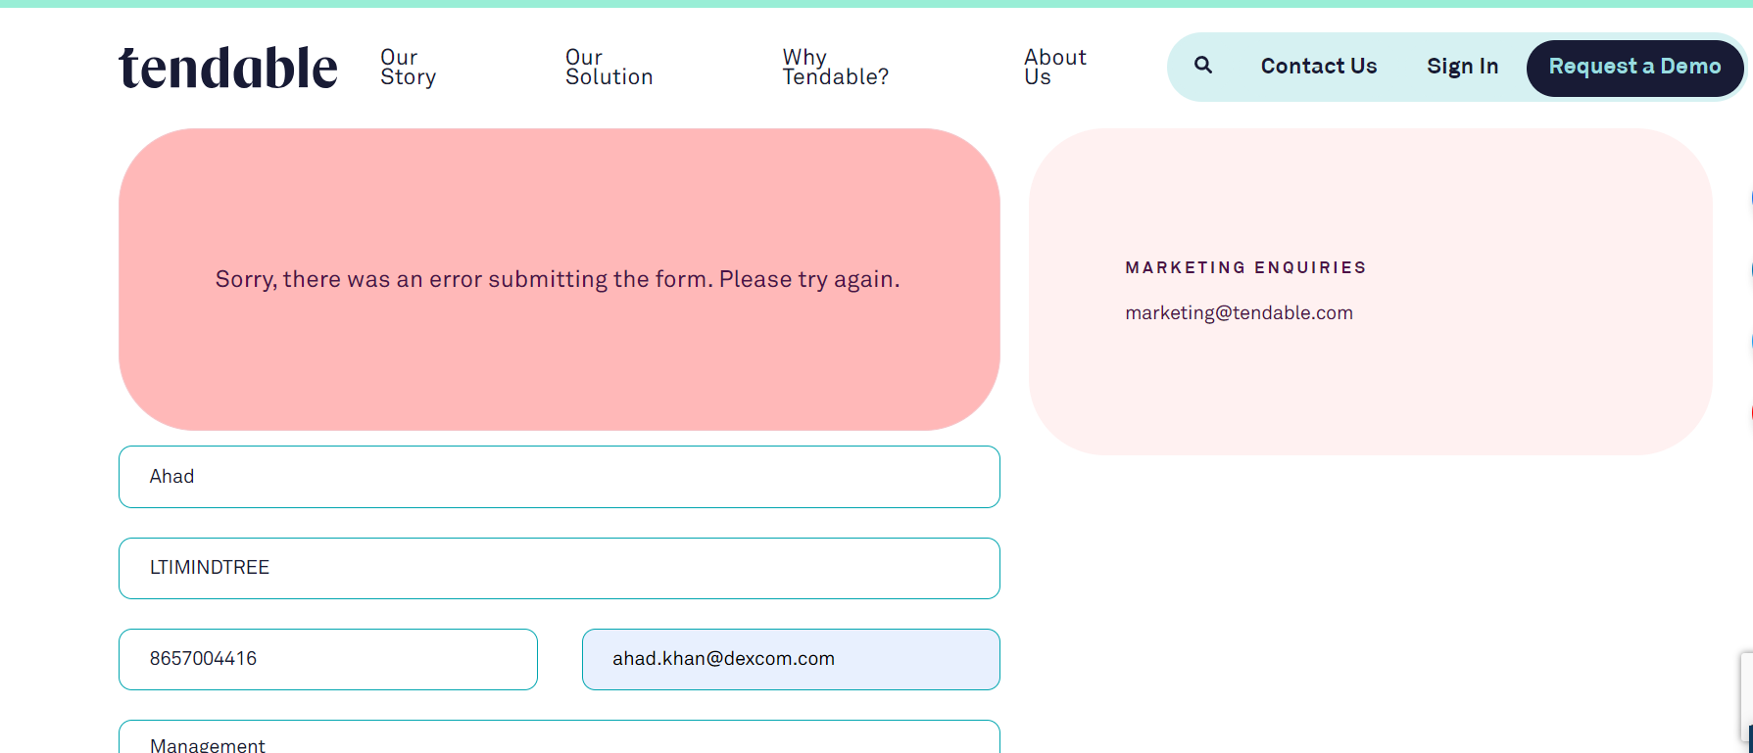

Actual Results

Form submitted without any error message displayed

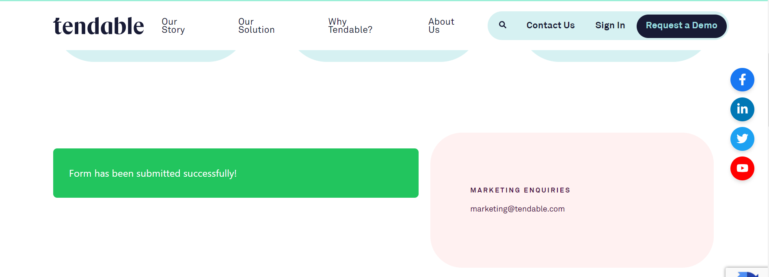

Severity of the defect : The defect will be termed as Critical defect as users interacting with the form would submit it without entering values in the message field which is a mandatory field.

Priority: Critical(P2)

State of the defect : Open

Conclusions : The defect is in open state and L2 developer is currently working on adding error message when the form is submitted keeping message field as empty
Change history : REF V2.0.03 , release cycle 3 (05-01-24) --> ongoing

References
https://www.tendable.com/contact-us
https://www.tendable.com/
Defect report : 111ABC121

